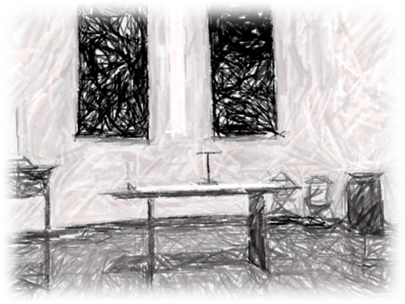

St Luke’s Worship for Mothering Sunday
22nd March 2020

As we begin our worship today, let us hold our world, nation and community in prayer.

A moment of silence…

Opening prayer

God of compassion,
whose Son Jesus Christ, the child of Mary,
shared the life of a home in Nazareth,
and on the cross drew the whole human family to himself:
strengthen us in our daily living
that in joy and in sorrow
we may know the power of your presence
to bind together and to heal;
through Jesus Christ your Son our Lord,
who is alive and reigns with you,
in the unity of the Holy Spirit,
one God, now and for ever
Amen

Confession

Lord God,
we have sinned against you;
we have done evil in your sight.
We are sorry and repent.
Have mercy on us according to your love.
Wash away our wrongdoing and cleanse us from our sin.
Renew a right spirit within us
and restore us to the joy of your salvation,
through Jesus Christ our Lord.
Amen.

Absolution

May God who loved the world so much
that he sent his Son to be our Saviour
forgive us our sins
and make us holy to serve him in the world,
through Jesus Christ our Lord.
Amen.

Bible Reading Luke 2:33-35

³³ The child’s father and mother marvelled at what was said about him. ³⁴ Then Simeon blessed them and said to Mary, his mother: “This child is destined to cause the falling and rising of many in Israel, and to be a sign that will be spoken against, ³⁵ so that the thoughts of many hearts will be revealed. And a sword will pierce your own soul too.”

Reflection from Fiona https://youtu.be/FJqUxtVBk5w

Prayer after reflection

God of compassion,
be close to those who are ill, afraid or in isolation.
In their loneliness, be their consolation;
In their anxiety, be their hope;
In their darkness, be their light;
Through him who suffered alone on the cross,
But reigns with you in glory,
Jesus Christ our Lord.
Amen.

Song In Christ Alone https://www.youtube.com/watch?v=ENtL_li4GbE

Intercessions
Let us pray to God,
who alone makes us dwell in safety:
For all who are affected by coronavirus, through illness or isolation or anxiety, that they may find relief and recovery: Lord, hear us,
Lord, graciously hear us.
For those who are guiding our nation at this time, and shaping national policies,
that they may make wise decisions:
Lord, hear us,
Lord, graciously hear us.
For doctors, nurses and medical researchers, that through their skill and insights
many will be restored to health:
Lord, hear us,
Lord, graciously hear us.
For the vulnerable and the fearful,
for the gravely ill and the dying,
that they may know your comfort and peace: Lord, hear us,
Lord, graciously hear us.
We commend ourselves, and all for whom we pray, to the mercy and protection of God.
Merciful Father,
accept these prayers for the sake of your Son, our Saviour Jesus Christ. Amen.

Rejoicing in the power of the Holy Spirit,
let us pray with confidence as our Saviour has taught us:

All Our Father in heaven,
hallowed be your name;
your kingdom come;
your will be done;
on earth as in heaven.
Give us today our daily bread.
Forgive us our sins,
as we forgive those who sin against us.
Lead us not into temptation;
but deliver us from evil.
For the kingdom, the power
and the glory are yours
now and for ever. Amen.

Closing Prayer
God has made us one in Christ
He has set His seal upon us
And, as a pledge of what is to come,
Has given us the Holy Spirit to dwell in our hearts.
Let us go in love and peace to serve the world.
In the name of Christ. Amen.

Please Note: A Call to Prayer – 7pm
Presidents of Churches Together in England have issued a call to prayer in the light of the Coronavirus pandemic. This is for all churches and people of prayer to join on Sunday 22nd March, Mothering Sunday.
"At such a time as this, when so many are fearful and there is great uncertainty, we are reminded of our dependence on our loving Heavenly Father and the future that he holds.
At 7pm (GMT) this Sunday, light a candle in the windows of your homes as a visible symbol of the light of life, Jesus Christ, our source and hope in prayer.”



